Hyperion EOS Firmware Update Utility Flow

1. USB to UART gender program installation
a. after executing the CP210x_Drivers.exe file, the following screen shows. Press Next button.

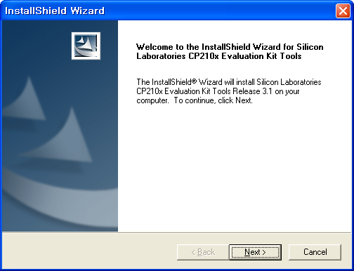

b. Agree License then press Yes.
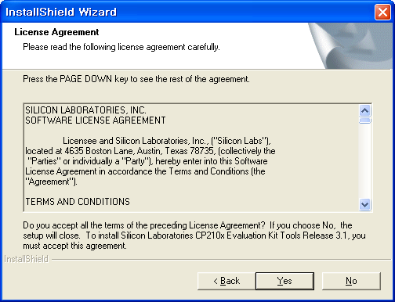

c. Choose a folder where the program is saved then press Next button.
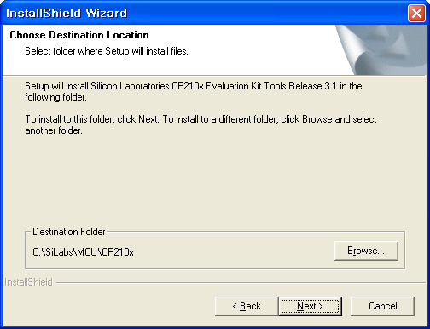

d. After program is complete then press Finish button.
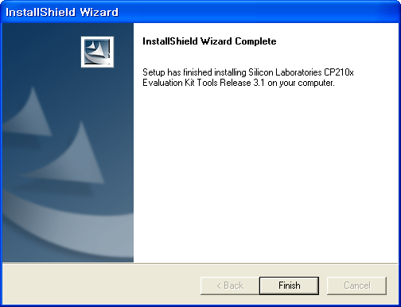

2. Execute Charge_Upgrader_WinApp
a. Connect the USB cable to the charger.
b. Double click and execute Charger_Upgrader_WinApp.exe
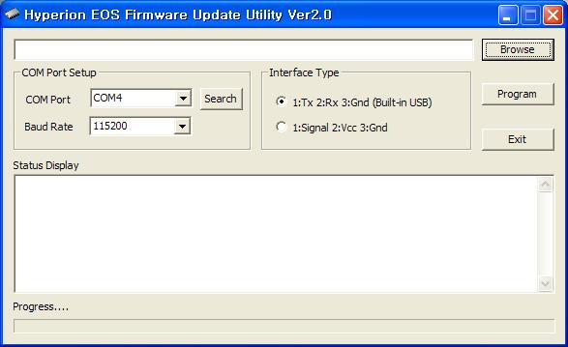

c. Setting communication port.
If you do not know the port number, press the Port searching button and check the connected port

d. Select the “CP2101 USB to UART Bridge Controller” list then press OK button.
If CP2101 list is not shown on the screen, disconnect and reconnect the UBS cable.
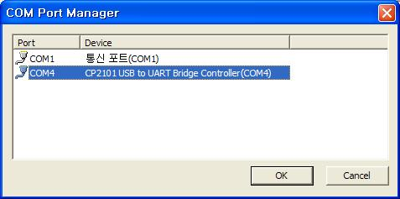

e. Communication port setting(2)
If you know the communication port number, choose its port number in the combo box. 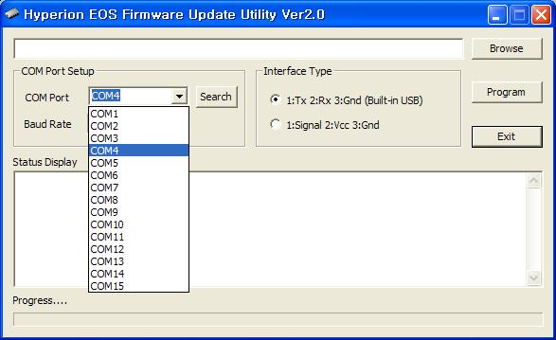

f. Setting communication speed.
Set the communication speed as 115200, and set Interface Type asBuilt-in USB.
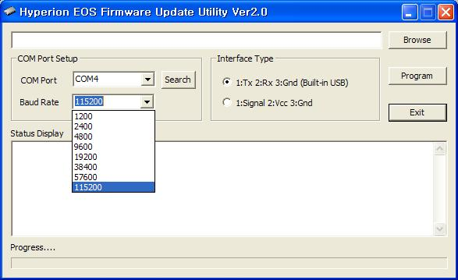

g. Choose firmware file to be updated.
Make sure to choose a proper firmware file compatible with a charger.
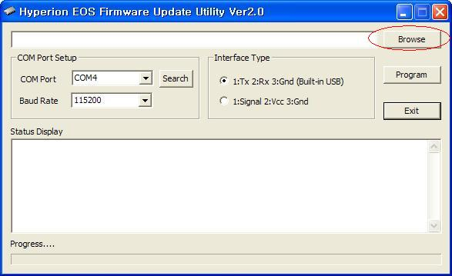

h. Firmware file to be updated.
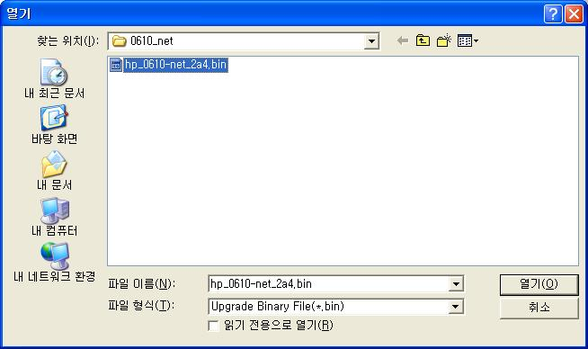

i. Screen where the file is selected.
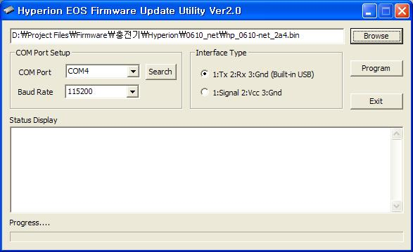

j. Now, start updating pressing the Program button.
After starting, when the below screen appears, connect the charger to the power so that download should function.
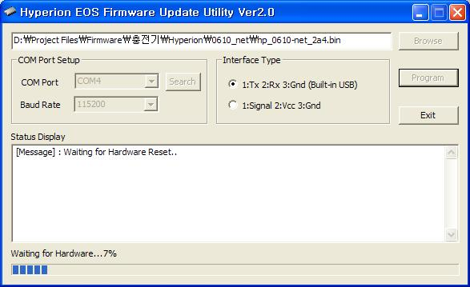

k. BootLoader update
If bootloader version of the charger is below than 2.5, the following message should appear then updated with the latest version.
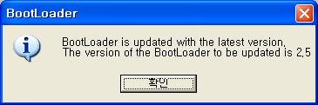

l. BootLoader update completion
When update is complete, “ Bootloader has been successfully updated “ should show on the screen of the charger.
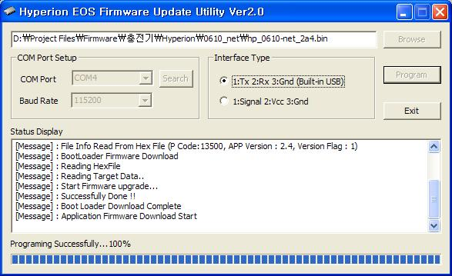

m. Preparing firmware update
when firmware update starts, the charger is automatically reset, and “PC COMMAND RESET....” should show on the screen of the charger.
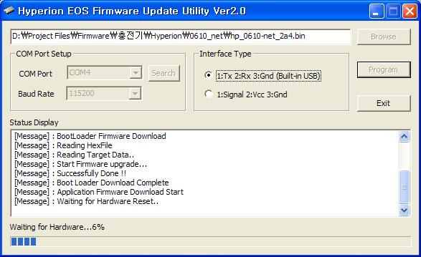

n. Firmware update processing
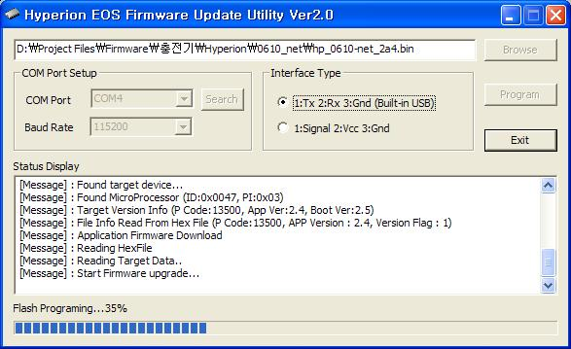

o. Firmware update completion
after firmware update, the charger is automatically on reset then normal operation is activated.
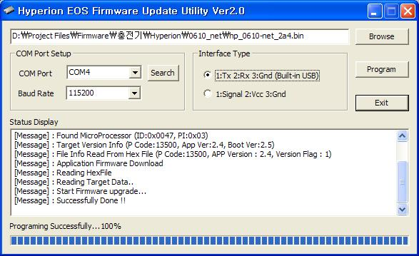

In case the booloader of the harger is latest version, it should be proceeded from j step to n step.

